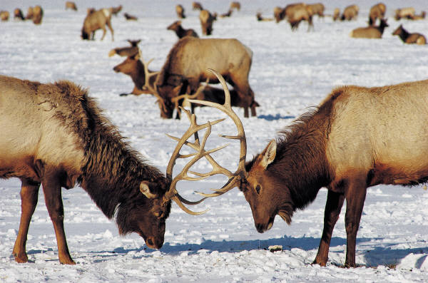
North Dakota Animal Project

North Dakota needs a “North Dakota State Animal”. We need one that lives here, is interesting, and will look nice representing our state. Your job is to research your animal. Find out what kind of habitat it lives in, what it eats, why is it important in the ecosystem, any interesting facts about it (does it migrate, hibernate, etc.). What is its classification (Kingdom, Phylum, Class, Order, Family, Genus, Species)? What does it eat? How does it get its food? Does it have any interesting habits? Is there any other information about your animal that is interesting or important?
Type a one page report about your animal telling why YOUR animal should be the North Dakota State Animal. Be PERSUASIVE!! Include all of the information you have found about your animal. Your report will be graded for grammar, spelling, and punctuation as well as for the information you provide about your animal.
You also need to create a campaign poster for your animal. It should include a picture of the animal and information to persuade us to vote for your animal for the North Dakota State Animal.
Finally, the last part of the project is to write and film a campaign commercial for your animal. It should be persuasive!!! It should also highlight the interesting things about your animal and how it would be a good representative of the state of North Dakota.

At the completion of the project, we will have a class vote for the animal we believe should be the North Dakota State Animal. The top 5 vote getters will get a prize!!

Paper | 5 Points | 4 Points | 3 Points | 2 Points | 1 Point
________ x 2 = | Info about habitat, diet, importance, classification included & complete. Lots of interesting facts too! | Info about habitat, diet, importance, classification included & mostly complete. A few other facts included. | Missing 1 piece of info but all other info is there. Included a couple of facts. | Missing about ½ the required info. Had one or less facts. | Missing more than ½ the required info. Did not include interesting facts.
_____________ | 1 or less spelling, grammar, punctuation errors. | 2-4 spelling, grammar, punctuation errors. | 5-7 spelling, grammar, punctuation errors. | 8-10 spelling, grammar, punctuation errors. | More than 10 spelling, grammar, punctuation errors.
______________ | Paper is 1 or more pages long. | Paper is 1-¾ pages long. | Paper is ½- ¾ pages long. | Paper is ½ - ¼ pages long. | Paper is less than ¼ pages long.
______________ | Paper is well written and in your own words. | Paper is well written and mostly in your own words. | Paper has a couple writing problems and/or has some copied info. | Paper has quite a few writing problems and/or lots of copied info. | Paper is mostly copied from your source.
Paper Total = _____________________ / 25 points

Poster | 5 Points | 4 Points | 3 Points | 2 Points | 1 Point
______________ | Picture is correct, is a major focal point, in color, and of good quality. | Picture is correct, is less of a focal point, in color, and/or quality is less. | Picture is correct, is less of a focal point, is black/white, quality is less. | Picture is correct, is not a focal point, is black/white, quality is poor. | Picture is not of the correct animal.
______________ | Everything on poster is spelled correctly. | 1-2 spelling errors. | 3-5 spelling errors. | 5-10 spelling errors. | 10+ spelling errors
______________ | Plenty of information is included to help us learn about your animal. |  | Some information is included. |  | Little to no information is included.
______________ | Extremely persuasive. It is obvious why yours should be chosen. | Persuasive but not quite a 5. | Half persuasive and half informational. Reasons to vote less obvious. | A little persuasive. You at least said to vote for your animal. | Not persuasive at all. There are no reasons to vote for it.
______________ | Poster is neat, tidy, and VERY creative. | Poster is neat and tidy. Creative but not a 5! | Poster is less neat and tidy. Creativity is ok. | Poster is less neat and tidy. Lacks creativity. | Poster is messy. Very little creativity involved.
Poster Total = _____________________ / 25 points

Commercial | 5 Points | 4 Points | 3 Points | 2 Points | 1 Point
_________x 2 = | Commercial is super creative. | Commercial is creative but not quite a 5! | Commercial is just a bunch of information and is lacking in creativity. | Commercial has some information but is not creative at all. | Commercial appears to be thrown together at the last minute.
_______________ | Is at least 30 seconds long. |  |  |  | Is less than 30 seconds long.
_________x 2 = | Is very persuasive. Gives us many reasons to vote for your animal. | Is persuasive but not quite a 5. | Is semi-persuasive. Gives us at least 2 reasons to vote for your animal. | Is less persuasive. Gives us less than 2 reasons to vote for your animal. | Is not persuasive at all.
Commercial Total = _____________________ / 25 points

______________ + ______________ + ______________ + ______________ = ________________________________
Paper Total Poster Total Commercial Group Grade Total
Total
Group Grading: Name:

10 (A) | 9 (B) | 8 (C) | 7 (D) | 6 (E)
Group member helped with all parts of the project. (Research, writing paper, planning/filming commercial, creating poster.) Group member worked well with the rest of the group.  This project couldn’t have been completed without him/her. | Group member helped with nearly all parts of the project. Group member worked well with the rest of the group. This project could have been completed without him/her but it wouldn’t have been done as well. | Group member helped with about ½ of the project. Group member worked well with the rest of the group with few problems. The person contributed to the project but we could have completed it without him/her. | Group member helped with less than ½ of the project. Group member had some problems working with the group. The person didn’t contribute too much to the project and we could have easily completed it without him/her. | Group member did almost nothing on the project. Group member had problems working with the group. The person contributed little or none to the project and we could have done it without him/her since we almost did anyway.

Group Member 1:
Grade: Reason:

Group Member 2:
Grade: Reason:

Group Member 3:
Grade: Reason:

Group Member 4:
Grade: Reason:

