Human Body System Project Name:

Your job is to research your system/organ and create a “box” which represents your organ or system. You need to include things to touch, see, and read in the box. You need to make it seem like we are actually passing through the system/organ. You need to include the parts of the system or organ.

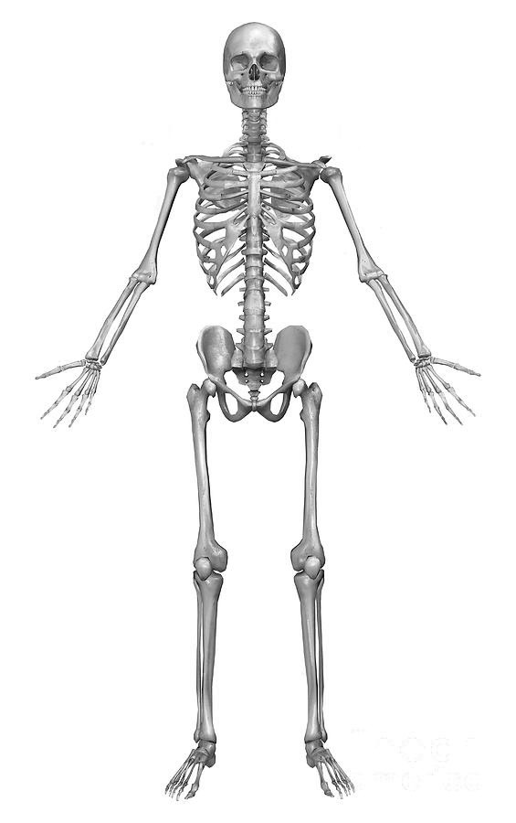
Skeletal System:
- Identify the 6 major parts.
- Describe 4 functions of the skeletal system.
- Describe the 5 types of bone tissues and what each type
does.
- Describe the 2 types of bone marrow and how they are
different.
- Explain how bones form and repair damage.
- List the three types of joints, explain how each works,
and give an example of each.
- How do ligaments and cartilage help the skeletal system
function?
- Explain 3 bone or joint injuries/diseases including
osteoporosis and arthritis.
- How can we keep bones healthy?
- How do bones help the body maintain homeostasis?

Grading:
- Daily Work – you will be given daily points for working
and staying on task and for cleaning up your area and
returning all materials to their place. This is an all or
nothing set of points each day.
- Information – you will be given points for answering all
questions and providing all required information
- Presentation – you will be graded on the delivery of and material included in your presentation
- Box – your box will be graded on looking like your system/organ/body part and for having all the
information included and/or parts represented in your box. Remember, your box should look like we are passing through or by your system. The box will also be graded for neatness and creativity.
- Peer/Self Evaluation – You will also be evaluating yourself and your peers on your individual
contributions to the group and the project.

Human Body System Project Name:

Your job is to research your system/organ and create a “box” which represents your organ or system. You need to include things to touch, see, and read in the box. You need to make it seem like we are actually passing through the system/organ. You need to include the parts of the system or organ.

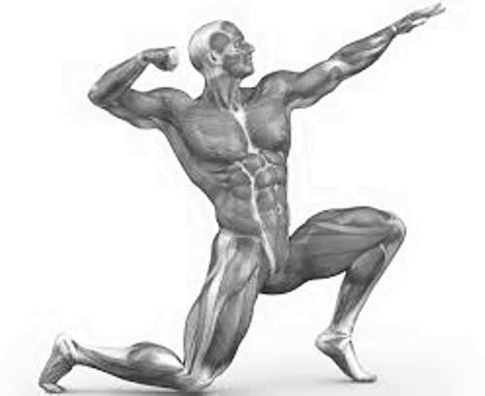
Muscular System:
- Identify 2 major parts.
- Describe 4 functions of the muscular system.
- Describe the 3 types of muscles.
- How does each type of muscle work?
- Explain the difference between tendons and
ligaments.
- How can we keep muscles healthy?
- How do muscles help the body maintain
homeostasis?
- Explain 3 muscle injuries/disorders including
fibromyalgia and muscular dystrophy.

Grading:
- Daily Work – you will be given daily points for
working and staying on task and for cleaning up
your area and returning all materials to their
place. This is an all or nothing set of points each day.
- Information – you will be given points for answering all questions and providing all required
information
- Presentation – you will be graded on the delivery of and material included in your presentation
- Box – your box will be graded on looking like your system/organ/body part and for having all the
information included and/or parts represented in your box. Remember, your box should look like we are passing through or by your system. The box will also be graded for neatness and creativity.
- Peer/Self Evaluation – You will also be evaluating yourself and your peers on your individual
contributions to the group and the project.

Human Body System Project Name:

Your job is to research your system/organ and create a “box” which represents your organ or system. You need to include things to touch, see, and read in the box. You need to make it seem like we are actually passing through the system/organ. You need to include the parts of the system or organ.

Integumentary System:
- Describe the 3 parts of the integumentary system.
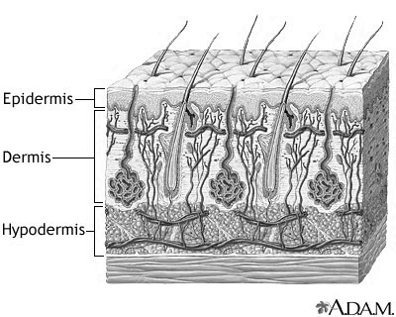
- Describe the 5 functions of integumentary system.
- List and describe the three layers of skin, their functions, and the structures found in each layer.
- Explain the functions of sweat.
- How can we keep skin, nails, and hair healthy?
- How does the sense of touch work?
- List 3 disorders/diseases of the integumentary system including psoriasis and eczema.
- How does the integumentary system help the body maintain homeostasis?
- Explain what a bruise is.
- Explain how a cut heals.
- Explain the 3 types of burns, what each damages, and the symptoms of each.
- What substances are made by integumentary
system and what functions do the substances have?

Grading:
- Daily Work – you will be given daily points for working and staying on task and for cleaning up your
area and returning all materials to their place. This is an all or nothing set of points each day.
- Information – you will be given points for answering all questions and providing all required
information
- Presentation – you will be graded on the delivery of and material included in your presentation
- Box – your box will be graded on looking like your system/organ/body part and for having all the
information included and/or parts represented in your box. Remember, your box should look like we are passing through or by your system. The box will also be graded for neatness and creativity.
- Peer/Self Evaluation – You will also be evaluating yourself and your peers on your individual
contributions to the group and the project.

Human Body System Project Name:

Your job is to research your system/organ and create a “box” which represents your organ or system. You need to include things to touch, see, and read in the box. You need to make it seem like we are actually passing through the system/organ. You need to include the parts of the system or organ.

Mouth:
- Explain how chemical digestion works in the mouth.
- List the substances made by the mouth and the functions of the substances.
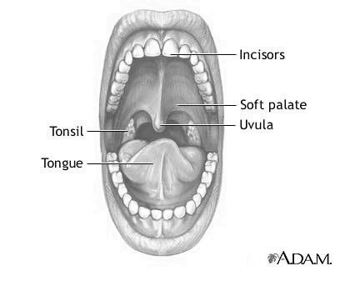
- Explain how mechanical digestion works in the mouth.
- Describe how taste works. Explain how the mouth is used by the respiratory system.
- List the types of teeth and the function of each.
- Explain the structure of a tooth.
- Describe the structure and function of the tongue.
- Explain 3 disorders of the mouth including tooth decay and canker sores.
- How does the mouth help the body maintain homeostasis?

Grading:
- Daily Work – you will be given daily points for working and staying on task and for cleaning up your area and returning all materials to their place. This is an all or nothing set of points each day.
- Information – you will be given points for answering all questions and providing all required information
- Presentation – you will be graded on the delivery of and material included in your presentation
- Box – your box will be graded on looking like your system/organ/body part and for having all the
information included and/or parts represented in your box. Remember, your box should look like we are passing through or by your system. The box will also be graded for neatness and creativity.
- Peer/Self Evaluation – You will also be evaluating yourself and your peers on your individual
contributions to the group and the project.

Human Body System Project Name:

Your job is to research your system/organ and create a “box” which represents your organ or system. You need to include things to touch, see, and read in the box. You need to make it seem like we are actually passing through the system/organ. You need to include the parts of the system or organ.

Digestive System (Not mouth, stomach, liver, gall bladder, or intestines)
- Explain what happens during digestion?
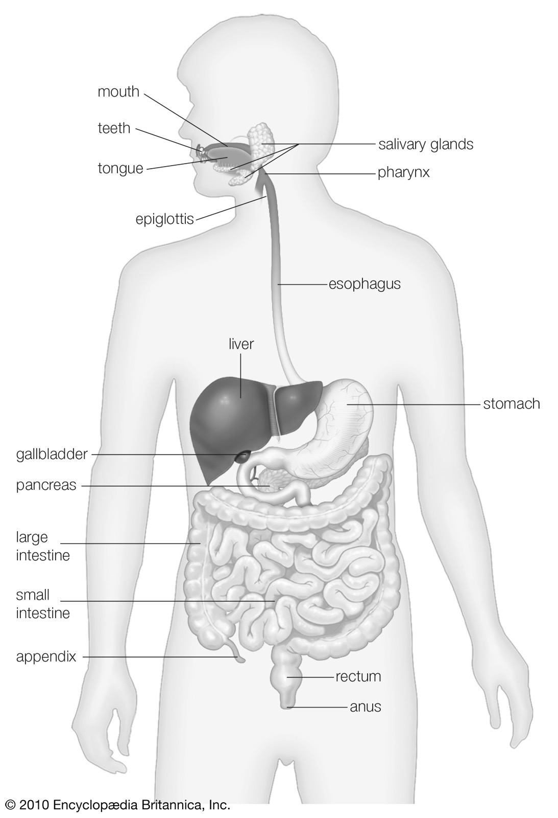
- Explain the 2 kinds of digestion.
- What are enzymes and what is the role of enzymes in digestion?
- What is the job of the esophagus?
- Explain the process of peristalsis and how it is important in digestion.
- Explain 3 digestive system disorders including heartburn/acid reflux and ulcer.
- How does the digestive system help the body maintain homeostasis?
- List the organs of the digestive system.
- Explain the path of food through the digestive system.
- How can we keep the digestive system healthy?

Grading:
- Daily Work – you will be given daily points for working and staying on task and for cleaning up your
area and returning all materials to their place. This is an all or nothing set of points each day.
- Information – you will be given points for answering all questions and providing all required information
- Presentation – you will be graded on the delivery of and material included in your presentation
- Box – your box will be graded on looking like your system/organ/body part and for having all the
information included and/or parts represented in your box. Remember, your box should look like we are passing through or by your system. The box will also be graded for neatness and creativity.
- Peer/Self Evaluation – You will also be evaluating yourself and your peers on your individual
contributions to the group and the project.

Human Body System Project Name:

Your job is to research your system/organ and create a “box” which represents your organ or system. You need to include things to touch, see, and read in the box. You need to make it seem like we are actually passing through the system/organ. You need to include the parts of the system or organ.

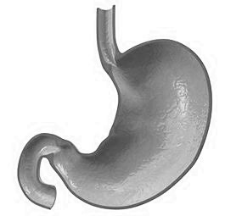
Stomach:
- Where is the stomach located?
- Describe the parts of the stomach.
- Explain how the stomach does mechanical digestion.
- Explain how the stomach does chemical digestion.
- What is chyme and how is it made?
- What substances are made by the stomach and what do
they do?
- Explain what enters the stomach and what it does there.
- Explain 3 disorders/surgeries of the stomach including gastric bypass surgery and gastritis.

Grading:
- Daily Work – you will be given daily points for working and staying on task and for cleaning up your area and
returning all materials to their place. This is an all or nothing set of points each day.
- Information – you will be given points for answering all questions and providing all required
information
- Presentation – you will be graded on the delivery of and material included in your presentation
- Box – your box will be graded on looking like your system/organ/body part and for having all the
information included and/or parts represented in your box. Remember, your box should look like we are passing through or by your system. The box will also be graded for neatness and creativity.
- Peer/Self Evaluation – You will also be evaluating yourself and your peers on your individual
contributions to the group and the project.

Human Body System Project Name:

Your job is to research your system/organ and create a “box” which represents your organ or system. You need to include things to touch, see, and read in the box. You need to make it seem like we are actually passing through the system/organ. You need to include the parts of the system or organ.

Intestines:
- What are the kinds 2 intestines and what is the main job of each?
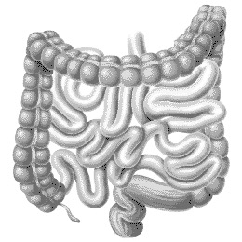
- What is the size (length and diameter) of each of the intestines?
- What are the parts of each intestine?
- What happens in each part of the intestines?
- What substances are made by the intestines and what do they do?
- Explain chemical digestion in the small intestine.
- What enzymes are involved in digestion in the intestines and where do those enzymes come from?
- Describe 3 diseases/disorders of the intestines including Crohn’s disease and diverticulitis.
- Where are the intestines located?

Grading:
- Daily Work – you will be given daily points for working and staying on task and for cleaning up your area and returning all materials to their place. This is an all or nothing set of points each day.
- Information – you will be given points for answering all questions and providing all required
information
- Presentation – you will be graded on the delivery of and material included in your presentation
- Box – your box will be graded on looking like your system/organ/body part and for having all the
information included and/or parts represented in your box. Remember, your box should look like we are passing through or by your system. The box will also be graded for neatness and creativity.
- Peer/Self Evaluation – You will also be evaluating yourself and your peers on your individual
contributions to the group and the project.

Human Body System Project Name:

Your job is to research your system/organ and create a “box” which represents your organ or system. You need to include things to touch, see, and read in the box. You need to make it seem like we are actually passing through the system/organ. You need to include the parts of the system or organ.

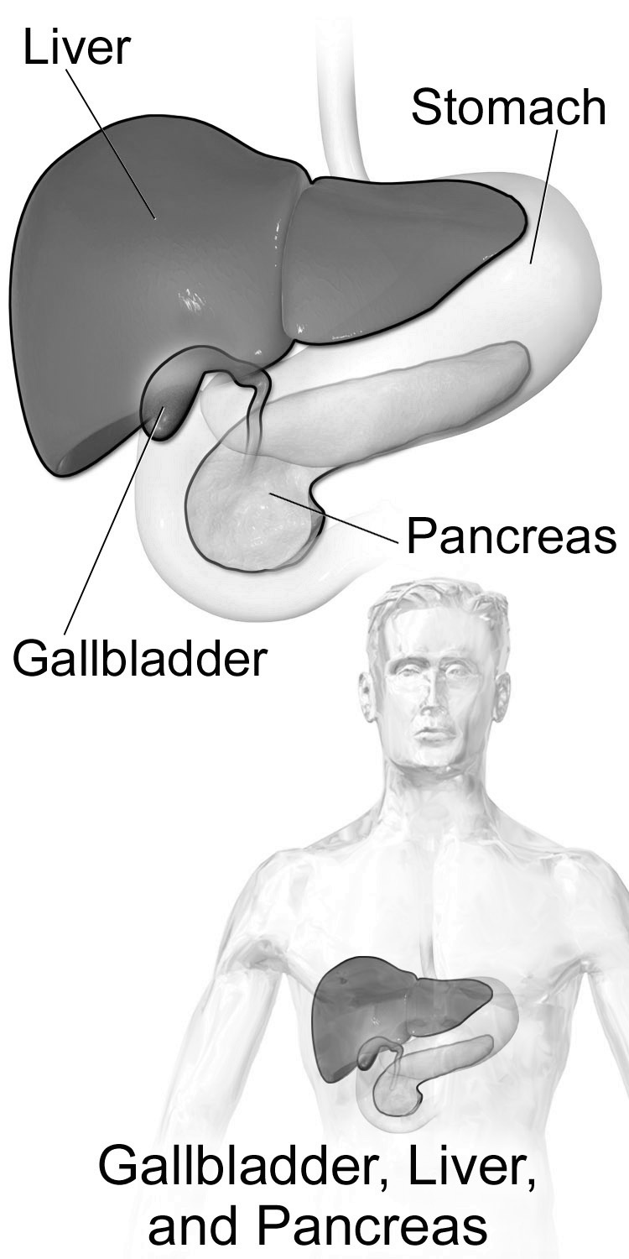
Liver and Gall Bladder and Pancreas:
- Describe the structures and functions of the liver.
- Describe the structures and functions of the gallbladder.
- Describe the structures and functions of the pancreas.
- Explain how each of these organs is involved in digestion.
- List other systems these organs may be involved with and what is their role(s)?
- Describe any substances made by these systems and what the functions of the substances are.
- Describe 3 disorders of these organs including gall stones and diabetes.
- Where are these organs located?

Grading:
- Daily Work – you will be given daily points for working and staying on task and for cleaning up your area and returning all materials to their place. This is an all or nothing set of points each day.
- Information – you will be given points for answering all questions and providing all required information
- Presentation – you will be graded on the delivery of and material included in your presentation
- Box – your box will be graded on looking like your system/organ/body part and for having all the information included and/or parts represented in your box. Remember, your box should look like we are passing through or by your system. The box will also be graded for neatness and creativity.
- Peer/Self Evaluation – You will also be evaluating yourself and your peers on your individual
contributions to the group and the project.

Human Body System Project Name:

Your job is to research your system/organ and create a “box” which represents your organ or system. You need to include things to touch, see, and read in the box. You need to make it seem like we are actually passing through the system/organ. You need to include the parts of the system or organ.

Excretory System:
- Explain the 3 functions of the excretory system.
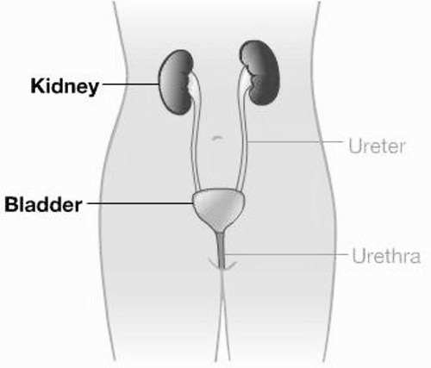
- Explain the types of excretion.
- Describe the 4 parts of the excretory system and what the job of each is.
- Where are the parts of the excretory system located?
- How does the excretory system help the body maintain homeostasis?
- Describe 3 disorders of the excretory system including urinary tract infection and kidney stones.
- Describe the structures of the kidneys and the functions of the structures.
- Explain 1st filtration and 2nd filtration.
- Explain what nephrons are and what they do.

Grading:
- Daily Work – you will be given daily points for working and staying on task and for cleaning up your
area and returning all materials to their place. This is an all or nothing set of points each day.
- Information – you will be given points for answering all questions and providing all required
information
- Presentation – you will be graded on the delivery of and material included in your presentation
- Box – your box will be graded on looking like your system/organ/body part and for having all the
information included and/or parts represented in your box. Remember, your box should look like we are passing through or by your system. The box will also be graded for neatness and creativity.
- Peer/Self Evaluation – You will also be evaluating yourself and your peers on your individual
contributions to the group and the project.

Human Body System Project Name:

Your job is to research your system/organ and create a “box” which represents your organ or system. You need to include things to touch, see, and read in the box. You need to make it seem like we are actually passing through the system/organ. You need to include the parts of the system or organ.

Respiratory System (Not the Lungs):
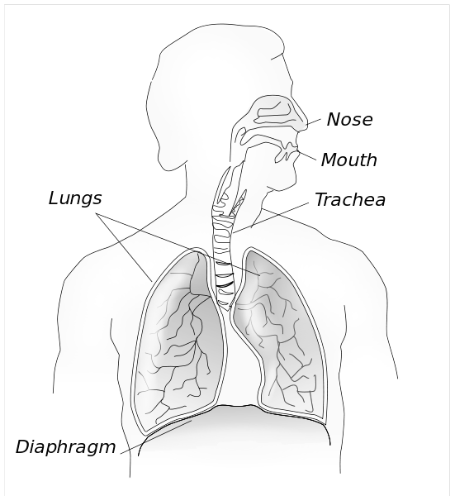
- What is the function of the respiratory system?
- Explain pulmonary respiration and cellular respiration and how the 2 are related.
- Identify the 4-6 parts of the respiratory system and the jobs of each part.
- Explain the relationship between the respiratory system and the cardiovascular system.
- Explain how the diaphragm works.
- Describe 3 disorders/diseases related to the respiratory system including bronchitis and asthma.
- Explain how the respiratory system helps the body maintain homeostasis.
- Explain how we can keep the respiratory system healthy.

Grading:
- Daily Work – you will be given daily points for working and staying on task and for cleaning up your area and returning all materials to their place. This is an all or nothing set of points each day.
- Information – you will be given points for answering all questions and providing all required
information
- Presentation – you will be graded on the delivery of and material included in your presentation
- Box – your box will be graded on looking like your system/organ/body part and for having all the
information included and/or parts represented in your box. Remember, your box should look like we are passing through or by your system. The box will also be graded for neatness and creativity.
- Peer/Self Evaluation – You will also be evaluating yourself and your peers on your individual
contributions to the group and the project.

Human Body System Project Name:

Your job is to research your system/organ and create a “box” which represents your organ or system. You need to include things to touch, see, and read in the box. You need to make it seem like we are actually passing through the system/organ. You need to include the parts of the system or organ.

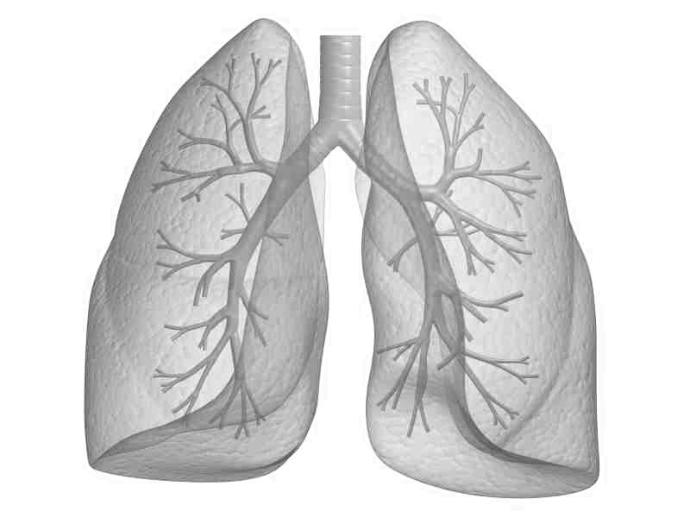
Lungs:
- What is the function of the lungs?
- How does air move into and out of the lungs?
- What happens to air in the lungs?
- Identify the parts of the lungs.
- What are alveoli and what is their function?
- What is gas exchange and how does it happen in the lungs?
- Describe 3 diseases/disorders of the lungs including emphysema and pneumonia.

Grading:
- Daily Work – you will be given daily points for working and staying on task and for cleaning up your area and returning all materials to their place. This is an all or nothing set of points each day.
- Information – you will be given points for answering all questions and providing all required
information
- Presentation – you will be graded on the delivery of and material included in your presentation
- Box – your box will be graded on looking like your system/organ/body part and for having all the
information included and/or parts represented in your box. Remember, your box should look like we are passing through or by your system. The box will also be graded for neatness and creativity.
- Peer/Self Evaluation – You will also be evaluating yourself and your peers on your individual
contributions to the group and the project.

Human Body System Project Name:

Your job is to research your system/organ and create a “box” which represents your organ or system. You need to include things to touch, see, and read in the box. You need to make it seem like we are actually passing through the system/organ. You need to include the parts of the system or organ.

Nose & Nasal Passageways:
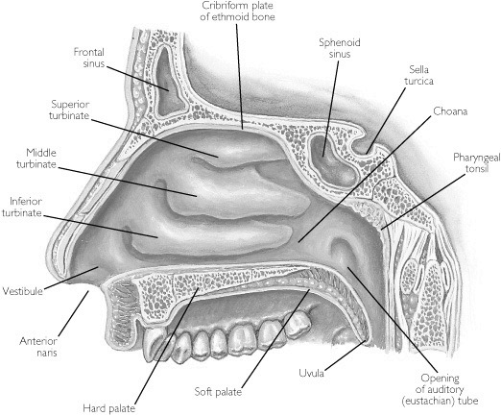
- What are the structures of the nose and nasal passageways and what is the function of each part?
- Explain how the sense of smell works.
- What systems is the nose part of? Explain its role in each system.
- What substances are produced by the nose and what is the job of each of these substances?
- What are sinuses? Where are they located? What is their function?
- Describe 3 diseases/disorders of the nose including sinusitis and rhinitis.

Grading:
- Daily Work – you will be given daily points for working and staying on task and for cleaning up your area and returning all materials to their place. This is an all or nothing set of points each day.
- Information – you will be given points for answering all questions and providing all required
information
- Presentation – you will be graded on the delivery of and material included in your presentation
- Box – your box will be graded on looking like your system/organ/body part and for having all the
information included and/or parts represented in your box. Remember, your box should look like we are passing through or by your system. The box will also be graded for neatness and creativity.
- Peer/Self Evaluation – You will also be evaluating yourself and your peers on your individual
contributions to the group and the project.

Human Body System Project Name:

Your job is to research your system/organ and create a “box” which represents your organ or system. You need to include things to touch, see, and read in the box. You need to make it seem like we are actually passing through the system/organ. You need to include the parts of the system or organ.

Circulatory System - Not the heart or blood:
- Identify the parts of the circulatory system and the function of each part.
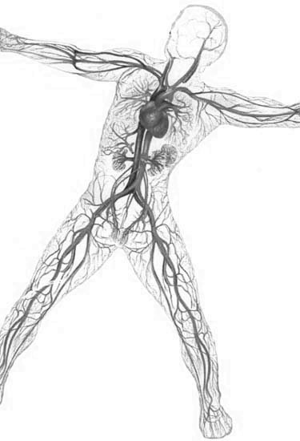
- Describe the 2 functions of the system.
- Describe 3 types of circulation.
- Explain the 3 types of blood vessels and the jobs of each type.
- Explain how the circulatory system helps the body to maintain homeostasis.
- Describe 3 non-heart related circulatory system diseases/disorders including atherosclerosis and hypertension.
- Explain how to keep the circulatory system healthy.
- Explain the path of blood through the body.

Grading:
- Daily Work – you will be given daily points for working and staying on task and for cleaning up your area and returning all materials to their place. This is an all or nothing set of points each day.
- Information – you will be given points for answering all questions and providing all required information
- Presentation – you will be graded on the delivery of and material included in your presentation
- Box – your box will be graded on looking like your system/organ/body part and for having all the
information included and/or parts represented in your box. Remember, your box should look like we are passing through or by your system. The box will also be graded for neatness and creativity.
- Peer/Self Evaluation – You will also be evaluating yourself and your peers on your individual
contributions to the group and the project.

Human Body System Project Name:

Your job is to research your system/organ and create a “box” which represents your organ or system. You need to include things to touch, see, and read in the box. You need to make it seem like we are actually passing through the system/organ. You need to include the parts of the system or organ.

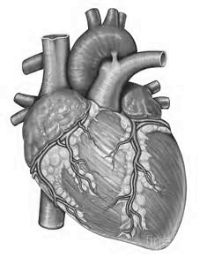
Heart:
- Identify the heart chambers and valves and explain how each part functions.
- Identify the main vessels that enter and exit the heart, where they go, and whether they carry oxygen-rich or oxygen-poor blood.
- Explain how the heart pumps blood.
- Explain the path of blood through the heart.
- Explain how the types of circulation are related to the heart.
- Describe 3 heart-related diseases/disorders including cardiomyopathy and hypoplastic left heart syndrome.

Grading:
- Daily Work – you will be given daily points for working and staying on task and for cleaning up your area and returning all materials to their place. This is an all or nothing set of points each day.
- Information – you will be given points for answering all questions and providing all required
information
- Presentation – you will be graded on the delivery of and material included in your presentation
- Box – your box will be graded on looking like your system/organ/body part and for having all the
information included and/or parts represented in your box. Remember, your box should look like we are passing through or by your system. The box will also be graded for neatness and creativity.
- Peer/Self Evaluation – You will also be evaluating yourself and your peers on your individual
contributions to the group and the project.

Human Body System Project Name:

Your job is to research your system/organ and create a “box” which represents your organ or system. You need to include things to touch, see, and read in the box. You need to make it seem like we are actually passing through the system/organ. You need to include the parts of the system or organ.

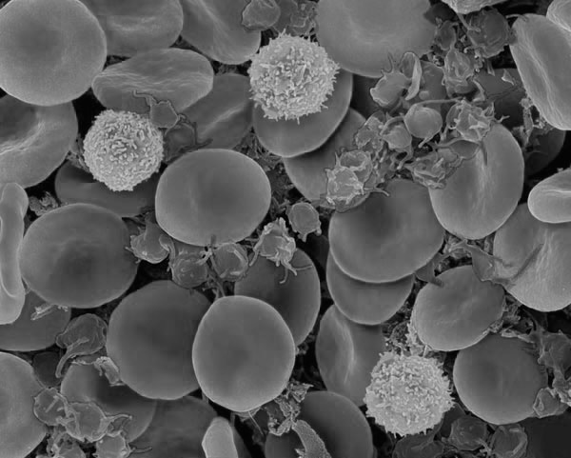
Blood:
- Describe the three main functions of blood.
- Describe the 4 main parts of blood and what the job of each is.
- Identify the systems that blood interacts with and describe those interactions.
- Explain the ABO blood type system.
- Explain the Rh factor part of blood type.
- Explain how blood helps the body maintain homeostasis.
- Describe 3 blood related diseases/disorders including leukemia and sickle-cell anemia.

Grading:
- Daily Work – you will be given daily points for working and staying on task and for cleaning up your area and returning all materials to their place. This is an all or nothing set of points each day.
- Information – you will be given points for answering all questions and providing all required
information
- Presentation – you will be graded on the delivery of and material included in your presentation
- Box – your box will be graded on looking like your system/organ/body part and for having all the
information included and/or parts represented in your box. Remember, your box should look like we are passing through or by your system. The box will also be graded for neatness and creativity.
- Peer/Self Evaluation – You will also be evaluating yourself and your peers on your individual
contributions to the group and the project.

Human Body System Project Name:

Your job is to research your system/organ and create a “box” which represents your organ or system. You need to include things to touch, see, and read in the box. You need to make it seem like we are actually passing through the system/organ. You need to include the parts of the system or organ.

Lymphatic System:
- Describe the 4 main functions of the lymphatic system.
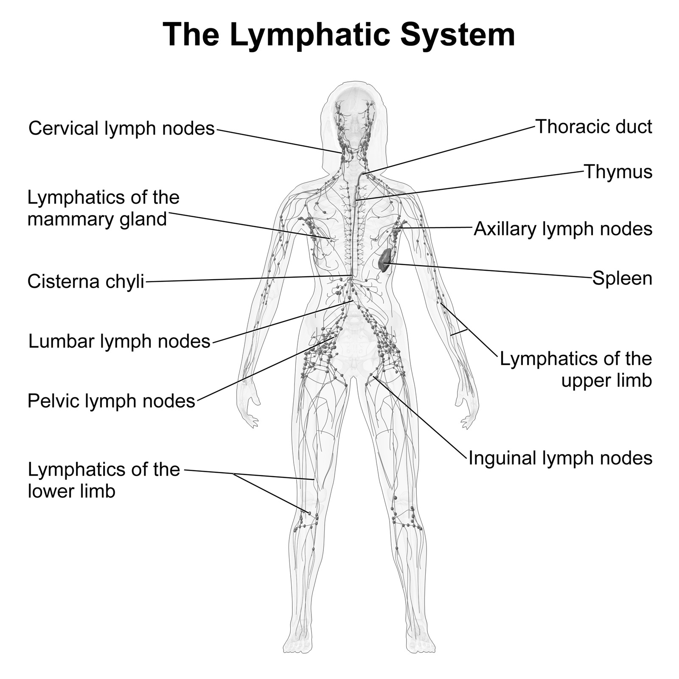
- Identify and describe 7 parts of the lymphatic system and the functions of each.
- Explain how the lymphatic system and the cardiovascular system are related.
- Explain how bone marrow and the thymus work together.
- Explain how the lymphatic system helps the body maintain homeostasis.
- Describe 3 lymph diseases/disorders including Hodgkin’s lymphoma and non-Hodgkin’s lymphoma.

Grading:
- Daily Work – you will be given daily points for working and staying on task and for cleaning up your area and returning all materials to their place. This is an all or nothing set of points each day.
- Information – you will be given points for answering all questions and providing all required
information
- Presentation – you will be graded on the delivery of and material included in your presentation
- Box – your box will be graded on looking like your system/organ/body part and for having all the
information included and/or parts represented in your box. Remember, your box should look like we are passing through or by your system. The box will also be graded for neatness and creativity.
- Peer/Self Evaluation – You will also be evaluating yourself and your peers on your individual
contributions to the group and the project.

Human Body System Project Name:

Your job is to research your system/organ and create a “box” which represents your organ or system. You need to include things to touch, see, and read in the box. You need to make it seem like we are actually passing through the system/organ. You need to include the parts of the system or organ.

Immune System:
- Explain the function of the immune system.
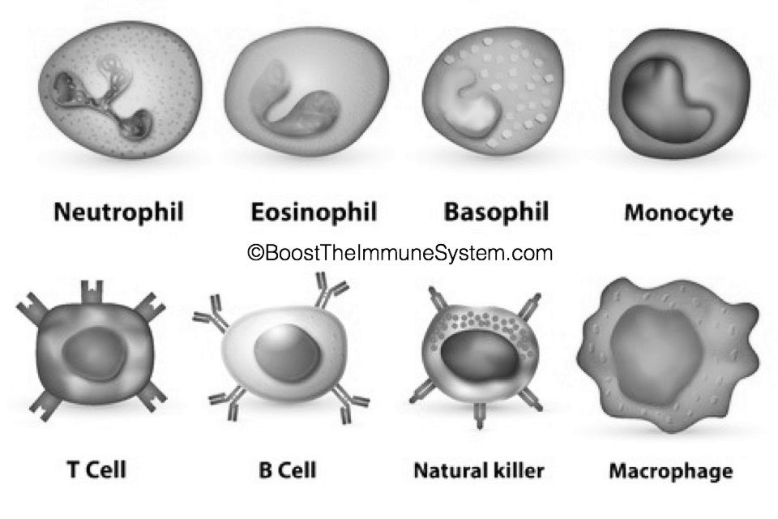
- Explain what the 1st line of defense does.
- Identify the 5 parts of the first line of defense of the immune
system and explain how each contributes.
- Explain what the 2nd line of defense does.
- Identify the 2 parts of the 2nd line of defense and explain how each contributes.
- Explain what the 3rd line of defense does.
- Identify 4 parts of the 3rd line of defense and explain how each contributes.
- Explain the two types of immunity.
- Explain how the immune system helps the body maintain homeostasis.
- Explain how vaccines work with the immune system to keep a person healthy.
- Describe 3 immune system diseases/disorders including allergies and lupus.

Grading:
- Daily Work – you will be given daily points for working and staying on task and for cleaning up your
area and returning all materials to their place. This is an all or nothing set of points each day.
- Information – you will be given points for answering all questions and providing all required
information
- Presentation – you will be graded on the delivery of and material included in your presentation
- Box – your box will be graded on looking like your system/organ/body part and for having all the
information included and/or parts represented in your box. Remember, your box should look like we are passing through or by your system. The box will also be graded for neatness and creativity.
- Peer/Self Evaluation – You will also be evaluating yourself and your peers on your individual
contributions to the group and the project.

Human Body System Project Name:

Your job is to research your system/organ and create a “box” which represents your organ or system. You need to include things to touch, see, and read in the box. You need to make it seem like we are actually passing through the system/organ. You need to include the parts of the system or organ.

Nervous System (Not sense organs or brain):
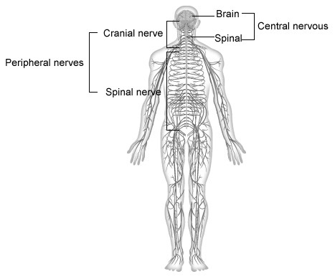
- Describe the 3 functions of the nervous system.
- Explain what a neuron is, what it looks like, and how it functions.
- Identify and describe the three types of neurons.
- Explain what a synapse is and what happens there.
- Explain what the peripheral nervous system is.
- Identify the 2 types of neurons involved in the peripheral nervous system and explain the difference between them.
- List the two parts of the peripheral nervous system and explain the differences between them.
- Explain how the peripheral nervous system’s role in helping the body maintain homeostasis.
- Describe 3 disorder/diseases of the peripheral nervous system including thoracic outlet syndrome and sciatica.

Grading:
- Daily Work – you will be given daily points for working and staying on task and for cleaning up your
area and returning all materials to their place. This is an all or nothing set of points each day.
- Information – you will be given points for answering all questions and providing all required
information
- Presentation – you will be graded on the delivery of and material included in your presentation
- Box – your box will be graded on looking like your system/organ/body part and for having all the
information included and/or parts represented in your box. Remember, your box should look like we are passing through or by your system. The box will also be graded for neatness and creativity.
- Peer/Self Evaluation – You will also be evaluating yourself and your peers on your individual
contributions to the group and the project.

Human Body System Project Name:

Your job is to research your system/organ and create a “box” which represents your organ or system. You need to include things to touch, see, and read in the box. You need to make it seem like we are actually passing through the system/organ. You need to include the parts of the system or organ.

Central Nervous System:
- Describe the parts of the central nervous system.
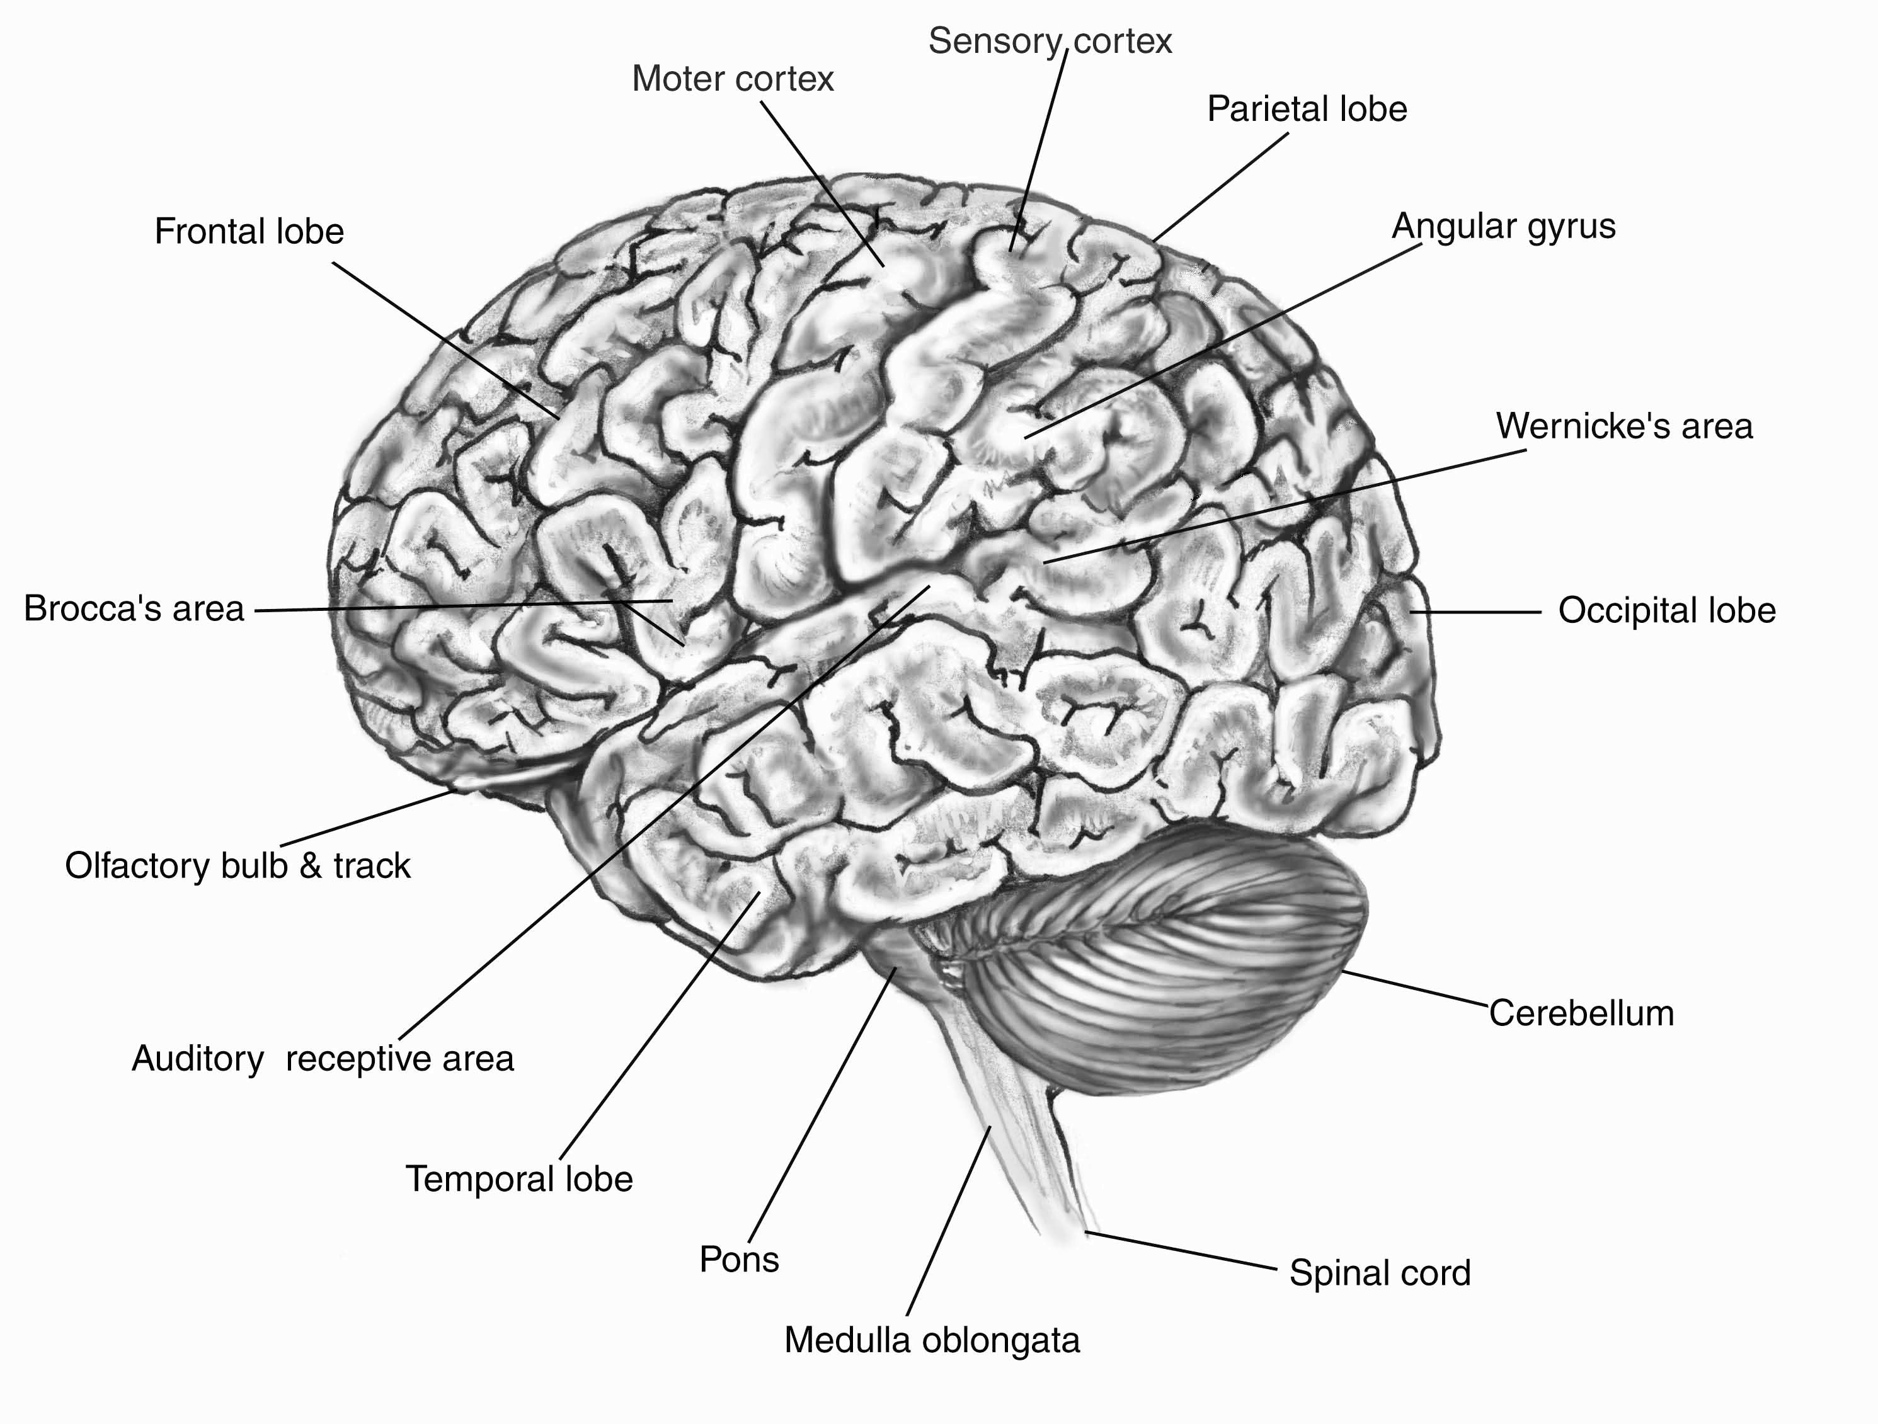
- Identify and describe the 3 main parts of the brain and the functions of each part.
- Identify the regions of the cerebrum and what each is responsible for.
- Explain the job of the central nervous system.
- Explain how the central nervous system and the peripheral nervous system are related and how they interact.
- Identify the main regions of the spinal cord.
- Explain the main functions of the spinal cord.
- Explain 3 ways to keep the nervous system healthy.
- Explain how the central nervous system helps the body to maintain homeostasis.
- Describe 3 disorder/diseases of the central nervous system including multiple sclerosis and stroke.

Grading:
- Daily Work – you will be given daily points for working and staying on task and for cleaning up your
area and returning all materials to their place. This is an all or nothing set of points each day.
- Information – you will be given points for answering all questions and providing all required
information
- Presentation – you will be graded on the delivery of and material included in your presentation
- Box – your box will be graded on looking like your system/organ/body part and for having all the
information included and/or parts represented in your box. Remember, your box should look like we are passing through or by your system. The box will also be graded for neatness and creativity.
- Peer/Self Evaluation – You will also be evaluating yourself and your peers on your individual
contributions to the group and the project.

Human Body System Project Name:

Your job is to research your system/organ and create a “box” which represents your organ or system. You need to include things to touch, see, and read in the box. You need to make it seem like we are actually passing through the system/organ. You need to include the parts of the system or organ.

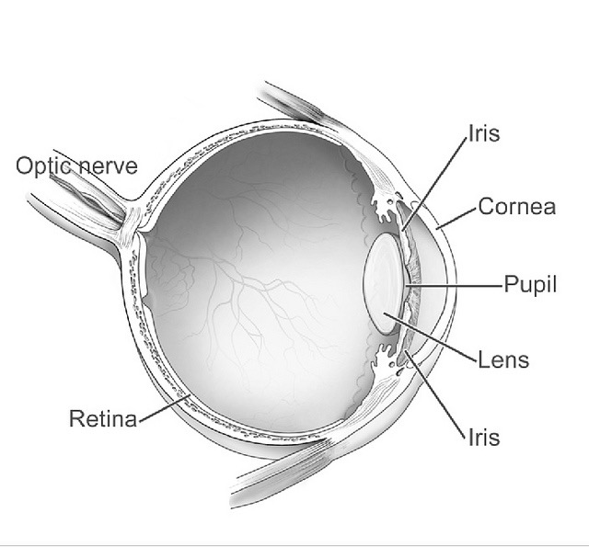
Eyes:
- Describe the function of eyes.
- Identify 6 eye structures and the functions of each structure.
- Explain how vision works.
- Explain nearsightedness and farsightedness.
- Identify the 2 types of photoreceptors and the function of each.
- Describe 3 disorders/diseases of the eye including macular degeneration and cataracts.
- Explain how to keep your eyes healthy.
- Explain how the eyes are related to the nervous system.

Grading:
- Daily Work – you will be given daily points for working and staying on task and for cleaning up your area and returning all materials to their place. This is an all or nothing set of points each day.
- Information – you will be given points for answering all questions and providing all required
information
- Presentation – you will be graded on the delivery of and material included in your presentation
- Box – your box will be graded on looking like your system/organ/body part and for having all the
information included and/or parts represented in your box. Remember, your box should look like we are passing through or by your system. The box will also be graded for neatness and creativity.
- Peer/Self Evaluation – You will also be evaluating yourself and your peers on your individual
contributions to the group and the project.

Human Body System Project Name:

Your job is to research your system/organ and create a “box” which represents your organ or system. You need to include things to touch, see, and read in the box. You need to make it seem like we are actually passing through the system/organ. You need to include the parts of the system or organ.

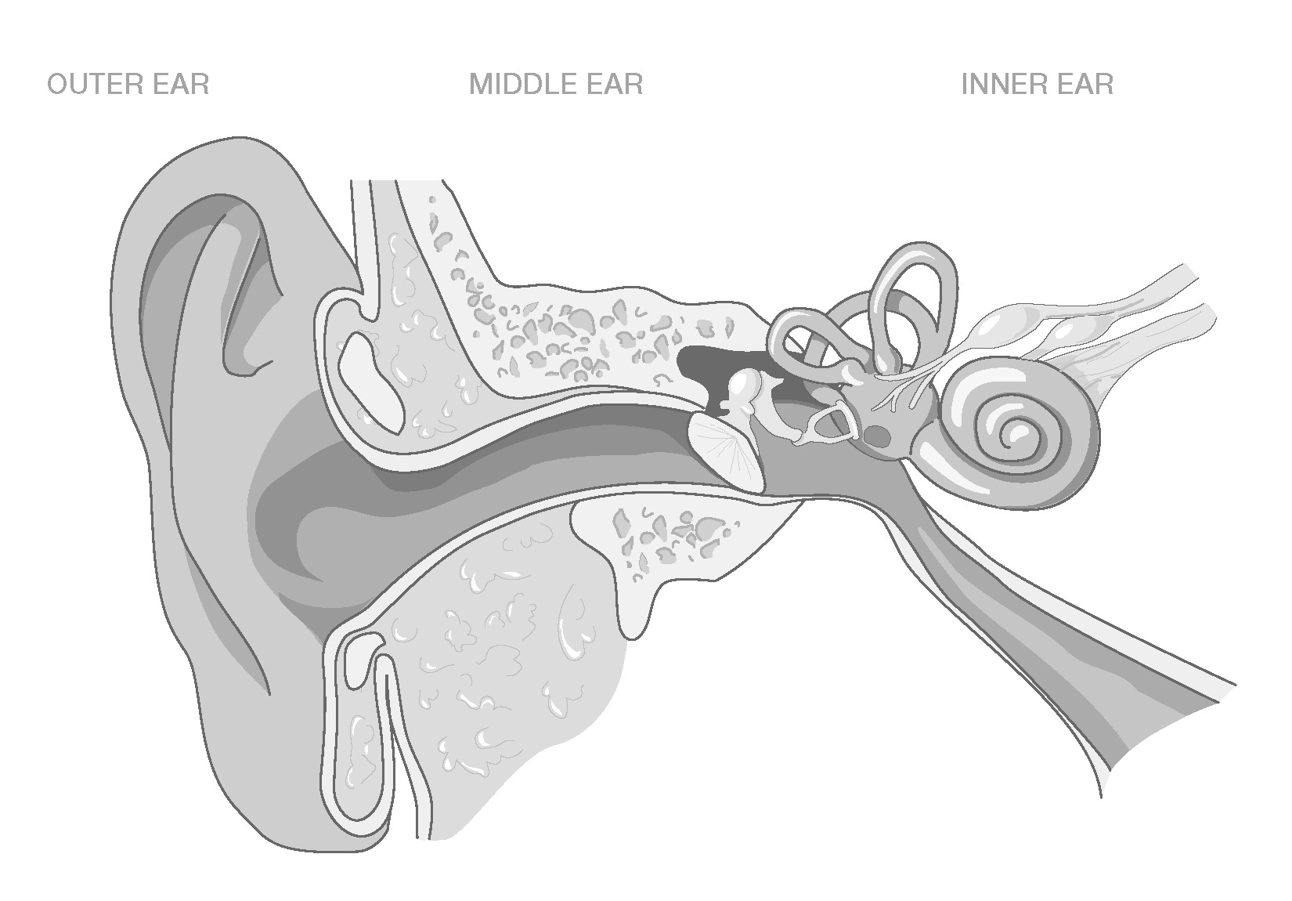
Ears:
- Explain the 2 functions of ears.
- Identify and describe the three parts of the ear.
- Explain how the eardrum works.
- Explain how hearing works.
- Identify and describe the parts of the ear related to balance.
- Explain how balance works.
- Describe 3 disorders/diseases of the ear including otitis media and Meniere’s disease.
- Explain how ears are related to the nervous system.

Grading:
- Daily Work – you will be given daily points for working and staying on task and for cleaning up your
area and returning all materials to their place. This is an all or nothing set of points each day.
- Information – you will be given points for answering all questions and providing all required
information
- Presentation – you will be graded on the delivery of and material included in your presentation
- Box – your box will be graded on looking like your system/organ/body part and for having all the
information included and/or parts represented in your box. Remember, your box should look like we are passing through or by your system. The box will also be graded for neatness and creativity.
- Peer/Self Evaluation – You will also be evaluating yourself and your peers on your individual
contributions to the group and the project.

Human Body System Project Name:

Your job is to research your system/organ and create a “box” which represents your organ or system. You need to include things to touch, see, and read in the box. You need to make it seem like we are actually passing through the system/organ. You need to include the parts of the system or organ.

Endocrine System:
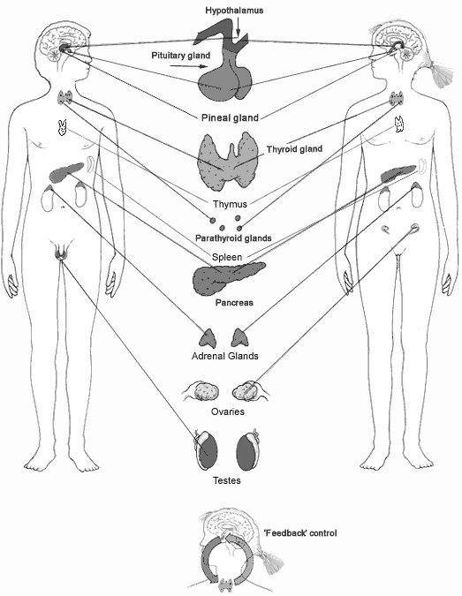
- Explain the function of the endocrine system.
- Explain what a hormone is and how it works.
- Identify 9 glands, describe their locations, and their functions in the body.
- Explain how the endocrine system helps the body maintain homeostasis.
- Explain what a negative feedback system is and how it helps the body maintain homeostasis.
- Explain what a positive feedback system is and how it helps the body maintain homeostasis.
- Explain how other body systems work with the endocrine system to maintain homeostasis.
- Describe 3 endocrine system disorders/diseases including acromegaly and Type I diabetes.

Grading:
- Daily Work – you will be given daily points for working and staying on task and for cleaning up your area and returning all materials to their place. This is an all or nothing set of points each day.
- Information – you will be given points for answering all questions and providing all required information
- Presentation – you will be graded on the delivery of and material included in your presentation
- Box – your box will be graded on looking like your system/organ/body part and for having all the
information included and/or parts represented in your box. Remember, your box should look like we are passing through or by your system. The box will also be graded for neatness and creativity.
- Peer/Self Evaluation – You will also be evaluating yourself and your peers on your individual
contributions to the group and the project.

Human Body System Project Name:

Your job is to research your system/organ and create a “box” which represents your organ or system. You need to include things to touch, see, and read in the box. You need to make it seem like we are actually passing through the system/organ. You need to include the parts of the system or organ.

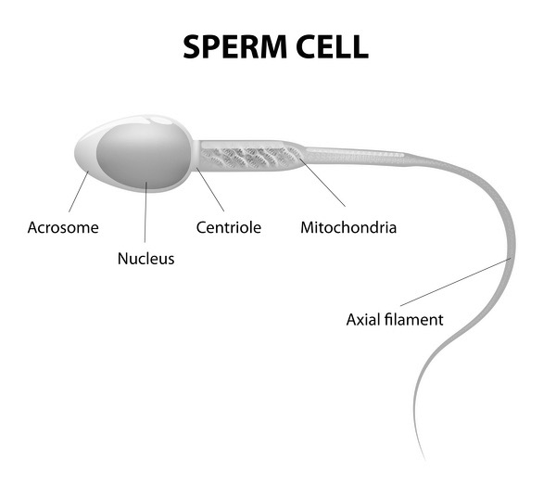
Male Reproductive System:
- Explain fertilization.
- Explain the main function of the male reproductive system.
- Identify 5 parts of the male reproductive system and explain the function of each.
- Explain how the parts of the male reproductive system work together.
- Describe the structure and function of sperm.
- Explain what happens in the lifetime of a sperm starting with how it is made and tracing its path through the male reproductive system until it leaves the body.
- Describe 3 disorders/diseases of the male reproductive system including enlarged prostate and testicular torsion.

Grading:
- Daily Work – you will be given daily points for working and staying on task and for cleaning up your
area and returning all materials to their place. This is an all or nothing set of points each day.
- Information – you will be given points for answering all questions and providing all required
information
- Presentation – you will be graded on the delivery of and material included in your presentation
- Box – your box will be graded on looking like your system/organ/body part and for having all the
information included and/or parts represented in your box. Remember, your box should look like we are passing through or by your system. The box will also be graded for neatness and creativity.
- Peer/Self Evaluation – You will also be evaluating yourself and your peers on your individual
contributions to the group and the project.

Human Body System Project Name:

Your job is to research your system/organ and create a “box” which represents your organ or system. You need to include things to touch, see, and read in the box. You need to make it seem like we are actually passing through the system/organ. You need to include the parts of the system or organ.

Female Reproductive System:
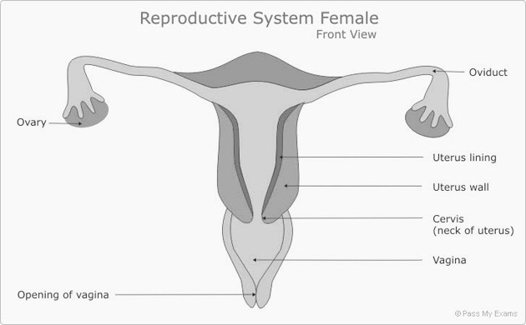
- Explain the main function of the female reproductive system.
- Identify and describe 5 parts of the female reproductive system and explain the function of each.
- Describe the egg and its development.
- Explain what the menstrual cycle is.
- Describe the 3 phases of the menstrual cycle.
- Explain how the parts of the female reproductive system work together.
- Explain what menopause is.
- Describe 3 disorders/diseases of the female reproductive system including polycystic ovary syndrome and pelvic inflammatory disease.

Grading:
- Daily Work – you will be given daily points for working and staying on task and for cleaning up your
area and returning all materials to their place. This is an all or nothing set of points each day.
- Information – you will be given points for answering all questions and providing all required
information
- Presentation – you will be graded on the delivery of and material included in your presentation
- Box – your box will be graded on looking like your system/organ/body part and for having all the
information included and/or parts represented in your box. Remember, your box should look like we are passing through or by your system. The box will also be graded for neatness and creativity.
- Peer/Self Evaluation – You will also be evaluating yourself and your peers on your individual
contributions to the group and the project.

Human Body System Project Name:

Your job is to research your system/organ and create a “box” which represents your organ or system. You need to include things to touch, see, and read in the box. You need to make it seem like we are actually passing through the system/organ. You need to include the parts of the system or organ.

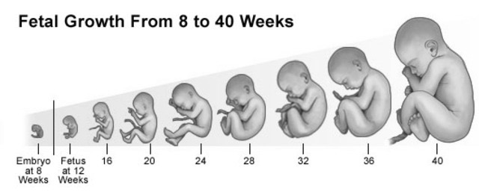
Human Development:
- Explain the process of fertilization.
- Explain the process of implantation.
- Discuss and describe what happens during the time from zygote to embryo.
- Discuss and describe what happens during the time between 9 weeks and birth.
- Explain 3 things that are important to fetal health and development.
- Explain the process of birth.
- Explain the stages of human development from birth to death.

Grading:
- Daily Work – you will be given daily points for working and staying on task and for cleaning up your
area and returning all materials to their place. This is an all or nothing set of points each day.
- Information – you will be given points for answering all questions and providing all required
information
- Presentation – you will be graded on the delivery of and material included in your presentation
- Box – your box will be graded on looking like your system/organ/body part and for having all the
information included and/or parts represented in your box. Remember, your box should look like we are passing through or by your system. The box will also be graded for neatness and creativity.
- Peer/Self Evaluation – You will also be evaluating yourself and your peers on your individual
contributions to the group and the project.

Body Box Grading Rubric Name:

 | 4 Points | 3 Points | 2 Points | 1 Point
Box Appearance  ( x 5) | All parts are represented and/or included. All required information is included. The box is just like passing through/by the body part. | ¾ parts are represented. Most information is included. The box has most components of the body part and is sort-of like the real body part. | ½ of parts are represented. ½ of the information is included and/or correct. The box has a component or two like the body part but isn’t much like the real body part. | Less than ½ of parts are represented. Little information is included and/or correct. The box is nothing like the actual body part.
Required Information  ( x 5) | All required information is included and correct. | Most required information is included and most is correct. | ½ of the required information is included and some is incorrect. | Little required information is included and/or much is incorrect.
Neatness and Creativity  ( x 5) | Box display is neat and organized. Models are 3-D and took a lot of time and effort to create. | Box display is less neat and organized. Some models are 3-D and took some time and effort to create. | Box display is a little messy. Some models are 3-D but didn’t take much time or effort to create. | Box display is very messy. There are no 3-D models. Little time or effort was required.
Presentation  (________ x 2) | Presentation was organized and included all information. PowerPoint/ pictures/etc. was used. Delivery was excellent. | Presentation was mostly organized and included most information. PowerPoint/ pictures/etc. was used. Delivery was good. | Presentation was sort of organized and/or included ½ of the required information. No PowerPoint/ pictures/etc. used. Delivery was ok but could be improved. | Presentation lacked organization and or information. No PowerPoint/ pictures/etc. used. Delivery needs much improvement.
Daily Work (5 points/day)
Group Grade Average
(10 points)
Total

