Vocabulary
Set up like this:

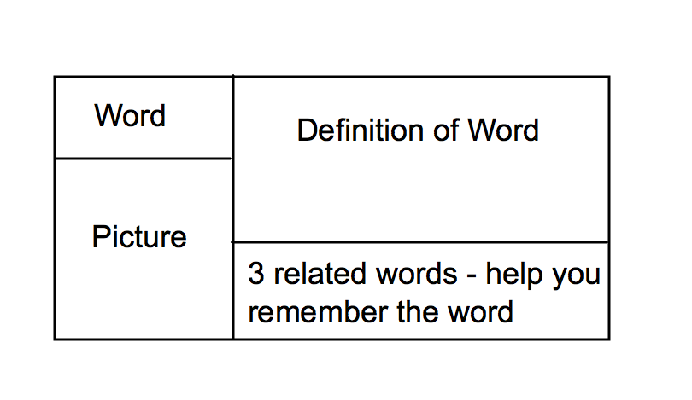
Front of Notecard
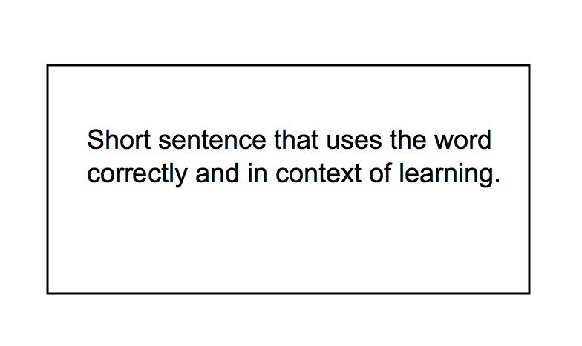
Back of Notecard
Definition - should be from your textbook.

Picture - should either be a picture of the word or a picture to help you remember the word

3 Related Words - should be words or phrases which help you to remember the definition

Short sentence - needs to use the word correctly, be in your own words, and not be just a restatement of the definition.

Example:
